Hands Up Scotland Survey 2026

Instructions and guidance for schools
August 2026
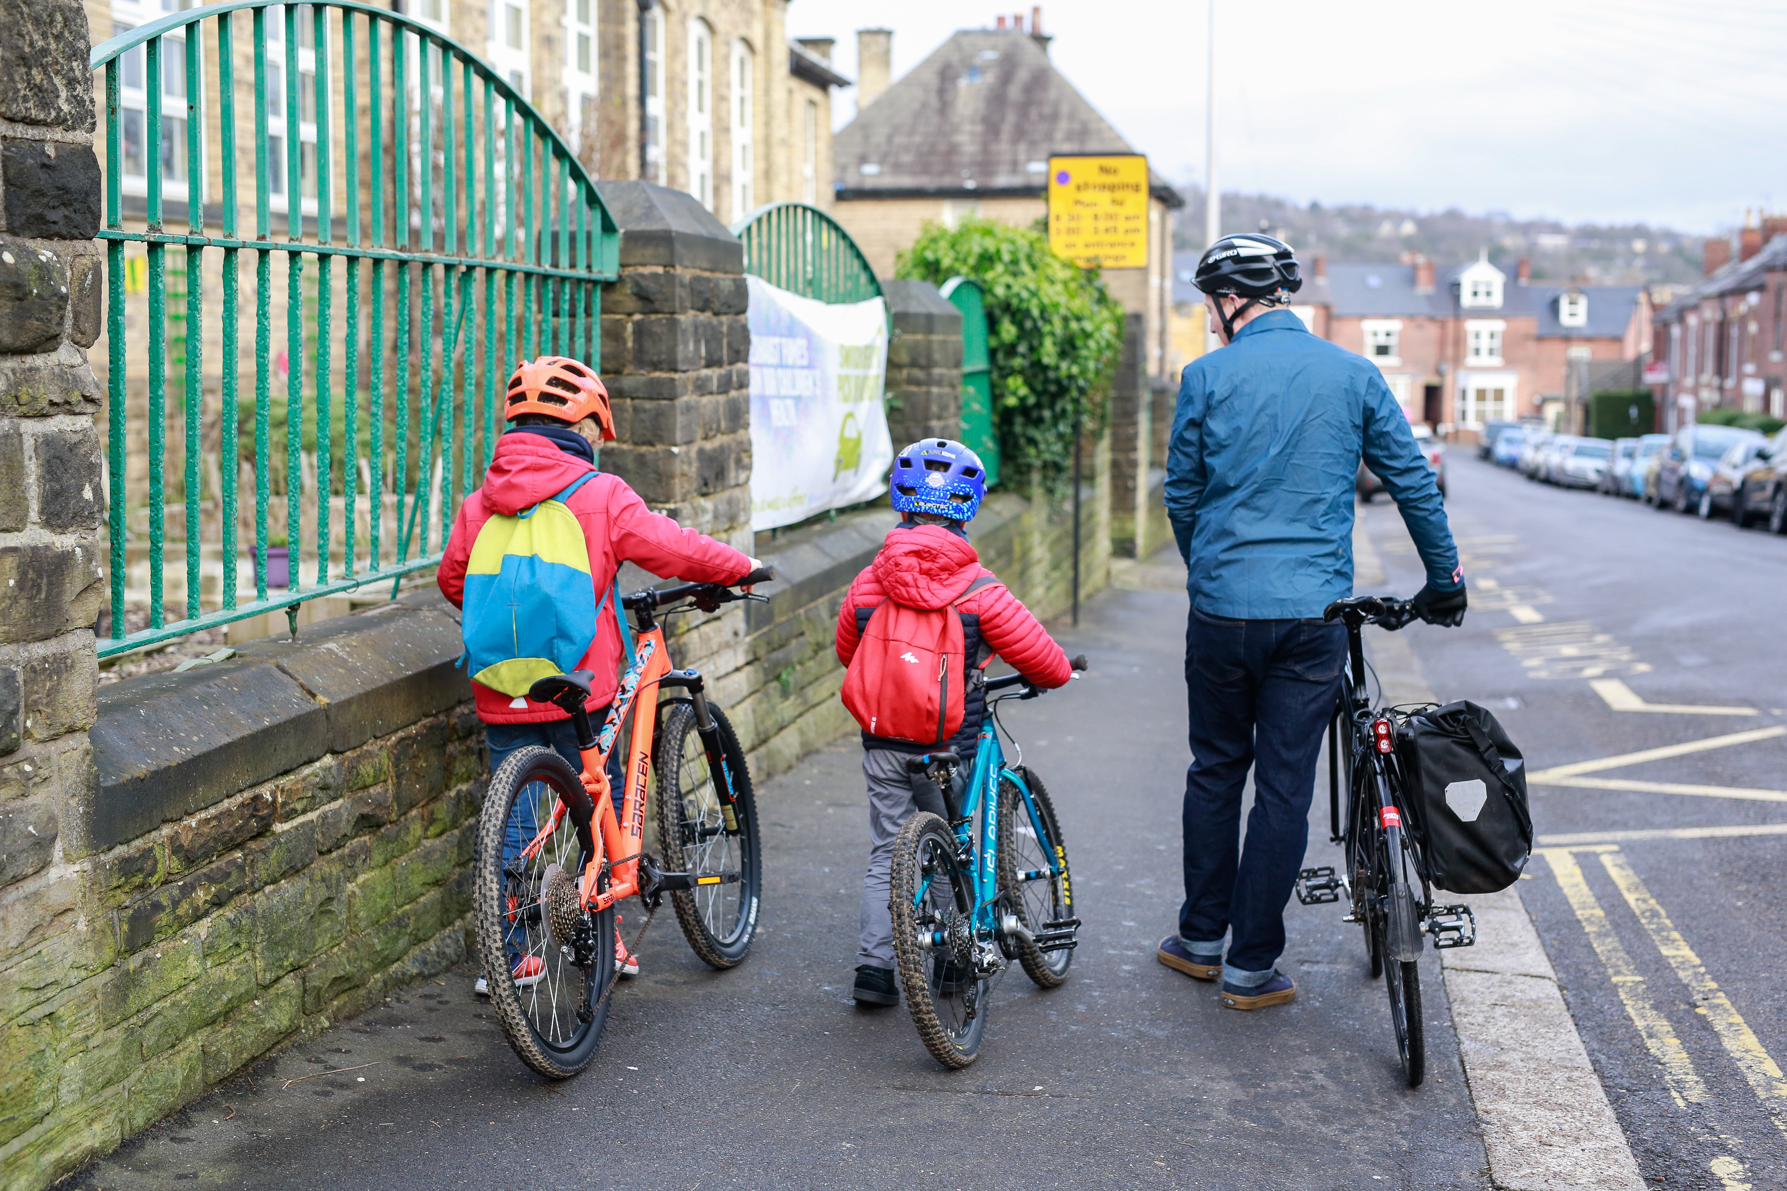

Walk Wheel Cycle Trust is the charity making it possible for everyone to walk, wheel and cycle. We work directly with communities to make change happen. Then we evidence the impact to influence policies to push those changes further. Because people-powered movement changes everything. Our health. Our wellbeing. Our world. www.walkwheelcycletrust.org.uk

Registered Charity No. SCO39263

Cover photograph credit: Chris Foster/Walk Wheel Cycle Trust, t
© 2020, Chris Foster all rights reserved

Welcome to Hands Up Scotland Survey 2026

The Hands Up Scotland Survey (HUSS) is the largest national dataset to look at how children travel to school across Scotland.

Following the passing of a Parliamentary Order on 1st June 2012, HUSS has been published as an Official Statistic in Scotland. This is a great achievement as the Official Statistic status acknowledges HUSS as a robust and accurate source of data, important for policy making on transport issues within Scotland.

These achievements have only been possible as a result of your continued support over the years and so we thank you for all your hard work! We are looking forward to working with you again this year.

HUSS 2026 key dates
Action | Date
Hands Up Scotland Survey 2026: Data collection week  Schools must conduct the survey between these dates. | 7th- 11th September 2026*
Schools must submit their survey results online by visiting:  https://online1.snapsurveys.com/s0xicy | Before 25th September 2026

Survey timing
Schools must conduct the survey between Monday 7th and Friday 11th of September 2026.
*The survey should ideally be conducted on one day within this week. We set aside a week for the survey so that schools can have the option of selecting the best day for them to conduct the survey given weather conditions or events.
It is important that the survey is not conducted during part of a Bike or Walk to School Week or any other special cycling or walking promotional activity. If you have any such activities planned, please notify the Walk Wheel Cycle Trust HUSS team: HandsUpScotland@walkwheelcycletrust.org.uk.
We are looking to increase participation in the survey only, not use the survey to increase walking and cycling levels.
Please note: School-level data for each local authority will not be published as part of the main report, but will be made available to the relevant local authority contact. In some instances, this will also be made available to third parties for research purposes on completion of a Hands Up Scotland Data Request pro forma, as agreed with Walk Wheel Cycle Trust and the relevant local authority.

Instructions
The necessary survey materials may be found enclosed in the email which included this guidance or alternatively on the Walk Wheel Cycle Trust website:
https://www.walkwheelcycletrust.org.uk/our-blog/projects/hands-up-scotland-survey/school-survey-packs-2026/
Preparing for the Hands Up Scotland Survey 2026
You’ve received your survey pack from your local authority or you’ve obtained this online. What should you do now to prepare to undertake the survey in your school or nursery?
Step 1: Nominate a HUSS leader within your school to co-ordinate the survey.
Your HUSS leader could be your school’s head teacher, school secretary or a teacher with an interest in the survey such as your school’s Eco Club leader.
Step 2: Decide on which day your school will conduct the survey.
The survey must be conducted during the specified survey week (7th to 11th September).
Each class in your school should conduct the survey on one day only.
- Top Tip: Try to plan for a day when all classes can take part - be aware of school trips!
- Top Tip for Nursery schools: If you are a nursery school with a morning and afternoon session, you may conduct the survey twice during the same day in order to capture responses from both your morning and afternoon sessions. Please make sure that you do not count the same child twice across morning and afternoon sessions.
- Composite classes: If you have a school with three or more age groups in one class (e.g. P1, P2, P3), please enter the data for all three age groups under the middle year group only (e.g. if, in one class, you receive responses from 10 pupils that are from across P1, P2 and P3, you would submit 0 responses under P1, 10 responses under P2 and 0 responses under P3.). If you have a school with two age groups in the same class (e.g. P1 and P2), please enter the data under the lower year group only (e.g. if, in one class, you receive 5 responses from across P1 and P2, you would submit 5 responses under P1 and 0 responses under P2).
Step 3: Decide where the survey will take place.
Usually, schools find it easiest to conduct the survey during the morning registration period.
Some smaller schools prefer to conduct the survey during a school assembly.
Some schools opt to conduct the survey during lesson time.
Step 4: Decide who will conduct the survey.
Most schools ask individual class teachers to conduct the survey with their class. However, in some schools, the nominated HUSS leader will visit each class in turn to conduct the survey.
Step 5: Prepare your survey forms, distribute them to all classes, and brief class teachers.
If your individual class teachers will be conducting the survey, please ensure all class teachers have a survey form and are aware of when and how to conduct the survey. Select the correct survey forms for your school – there are forms for nursery, primary and secondary.
- Top Tip: Fill in the class names on the survey forms before you hand the forms out to teachers.
Survey Day: Conducting the Survey
The chosen date for the survey in your school has arrived. How should teachers / the HUSS leader conduct the survey?
Step 1: Count the number of pupils present and note this on the survey form.
Step 2: Tell pupils you will read the question and answer options through twice – during the first reading, pupils should listen only, and on the second reading, they should answer the question by putting their hand up. Read the question and answer options in the order they appear.
Step 3: Ask pupils the survey question: “How do you normally travel to school?”
As you read through the answer options for the second time, count the number of hands and note this on the survey form.
- ‘Walk’ also covers those that use a manual or electric wheelchair on a pavement (wheeling). However, if the child and wheelchair are normally transported in a motorised vehicle, please record them against the appropriate motorised vehicle category (e.g. if the child and the wheelchair is transported on a bus, record them against ‘Bus’)
- ‘Other’ covers (but is not restricted to) children who say they normally travel by train, subway or ferry
- If a child says that they use a mix of modes to get to school, tell them they should put their hand up for the mode that makes up the largest amount of their journey time.
If a pupil is absent during the survey, they should not be included in the survey results at a later date.
- Top Tip: Asking pupils to put their hand down once you have pointed at them to show you have counted them can make tallying up the responses easier.
Step 4: Add up the total number of pupils that responded and note this in the total box. Note that data must be submitted at a whole class level as a minimum (it could also be submitted at a whole year group, or whole school, level) and that pupils should not be submitting data at an individual pupil level.
Step 5: Return the survey forms to the school office or the nominated HUSS leader.
Submitting your school’s results
You’ve now conducted the survey with all classes in your school. What’s next?
Step 1: Check survey forms have been received from all teachers.
- Top Tip: It can help to create a checklist and mark each class off as you receive the forms.
Step 2: Collate your results
If you have multiple classes in each year group, you will need to add up the results for each year group. You can use a separate survey form to make note of the totals for each year group. If you only have one class per year group, you can skip this step.
Step 3: Submit your results
Please submit your results online before the survey closes on Friday 25th September 2026.
At the beginning of survey week, we sent your school an email containing a unique link to log in to the survey. If you did not receive this email, you can access the survey by entering your school’s SEED number or nursery’s CSN at the following link: https://online1.snapsurveys.com/s0xicy
For school result submissions, the online survey will ask you to specify whether you are submitting results for all classes or year groups, some classes or year groups, or a single class or year group. For nursery results submissions, the online survey will ask you to specify whether you are submitting results for the AM session, PM session or the AM and PM session / Whole nursery. You are able to log into the survey multiple times to provide multiple data submissions (i.e. if you wanted to submit AM session and PM session data at separate times for a nursery).
- Top Tip: If you have an Additional Support Needs (ASN) element to your school, you can submit the ASN pupil data as a separate survey entry from the mainstream pupil data by logging in to the survey again using the same SEED number and indicating that the submission is for an SEN school, to differentiate it. It is helpful to leave a note in the comments section to flag this.
If you have any issues logging into the survey, please get in touch with your local authority contact or with us directly via the contact information provided at the start of this guidance.
Complete all of the information and click submit. Your school should now receive an e-receipt to confirm we have received your results. Sometimes this email can take a little while to come through, so don’t worry if you don’t receive it right away.
Step 4: You’re all done!
Please retain a copy of your school’s results in case we have any questions about your submission.
Thank you again for participating in the Hands Up Scotland Survey 2026!

General assistance and support
If you have any queries regarding the information in this document please do not hesitate to contact your local authority representative or the HUSS team:
Email: HandsUpScotland@walkwheelcycletrust.org.uk
Tel: 0131 346 1384.

School SEED numbers can be found at https://www.gov.scot/publications/school-contact-details/
Nursery CSN numbers can be found at http://www.careinspectorate.com/index.php/statistics-and-analysis/data-and-analysis

